LAB 1:-

QUE 1) Write a java program to print a “Hello World” message.

INPUT:-

**package** my.anuddep;

**public** **class** Helloworld {

**public** **static** **void** main(String[] args) {

// **TODO** Auto-generated method stub

System.***out***.println("Hello World");

}

}

OUTPUT:-

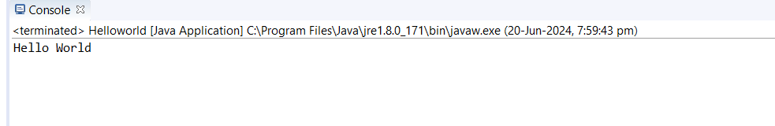

QUE2:-Write a program for addition of two number entered by the user.

INPUT:-

**package** Add;

**import** java.util.Scanner;

**public** **class** additionOfTwoNumber {

**public** **static** **void** main(String[] args) {

// **TODO** Auto-generated method stub

**int** num1,num2,result;

Scanner sc= **new** Scanner(System.***in***);

//int a=3,b=3,sum;

System.***out***.println("enter the first number");

num1=sc.nextInt();

System.***out***.println("enter the second number");

num2=sc.nextInt();

sc.close();

result=num1+num2;

System.***out***.printf("%d+%d=%d",num1,num2,result);

}

}

OUTPUT:-

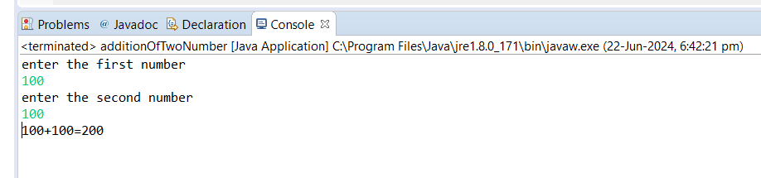

QUE3:-Write a java program to check whether a given number is even or odd

INPUT:-

**package** evenOddProgram;

**import** java.util.Scanner;

**public** **class** EvenOddProgram {

**public** **static** **void** main(String[] args) {

// **TODO** Auto-generated method stub

**int** num;

System.***out***.println("enter the integer number: ");

Scanner sc=**new** Scanner(System.***in***);

num=sc.nextInt();

**if**(num%2==0){

System.***out***.println("the entered number is even");

}

**else**

{

System.***out***.println("entered number is odd");

}

sc.close();

}

}

OUTPUT:-

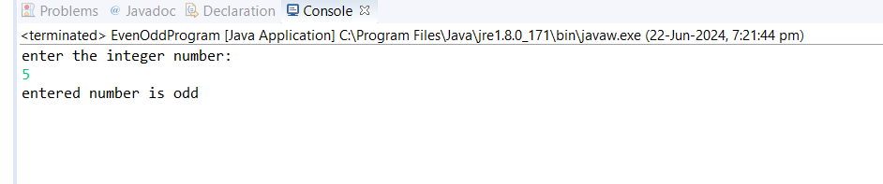

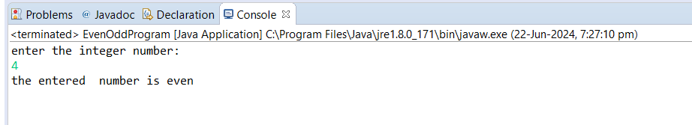

QUE4:- Write a java program that compares two number and prints the larger one OR

Write a java program to find greatest of 3 numbers

INPUT:-

**package** narrowingWidening;

**import** java.util.Scanner;

**public** **class** ThreeGreaterNumber {

**public** **static** **void** main(String[] args) {

// **TODO** Auto-generated method stub

Scanner sc=**new** Scanner(System.***in***);

**int** num1,num2,num3;

System.***out***.println("enter the first number: ");

num1=sc.nextInt();

System.***out***.println("enter the second number: ");

num2=sc.nextInt();

System.***out***.println("enter the third number: ");

num3=sc.nextInt();

**if**(num1>=num2 && num1>=num3) {

System.***out***.println("num1 is greater");

}

**else** **if**(num2>=num1 && num2>=num3) {

System.***out***.println("num2 is greater");

}

**else** {

System.***out***.println("num3 is greater");

}

sc.close();

}

}

OUTPUT:-

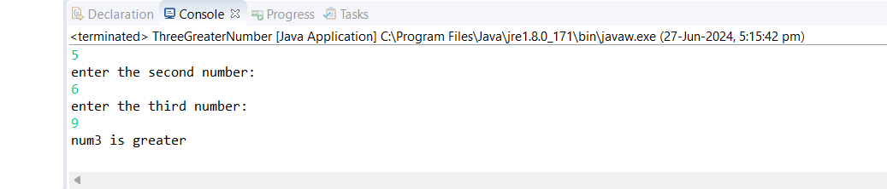

QUE5:- CREATE A CALULATOR IN JAVA USING ADDITION SUBTRACTION, MULTIPLICATION, DIVIDE.

INPUT:-

**package** Calculator;

**public** **class** calculator {

**public** **static** **void** main(String[] args) {

// **TODO** Auto-generated method stub

**int** a=4, b=5,sum;

sum=a+b;

**int** c=6, d=5,sub;

sub=c-d;

**int** e=9,f=4,multi;

multi=e*f;

**int** g=2,m=10, divide;

divide=m/g;

System.***out***.println("the sum of the two number is: "+sum);

System.***out***.println("the subtraction of two number is: "+sub);

System.***out***.println("the multiplication of two number is: "+multi);

System.***out***.println("the division of two number is: "+ divide);

}

}

OUTPUT:-

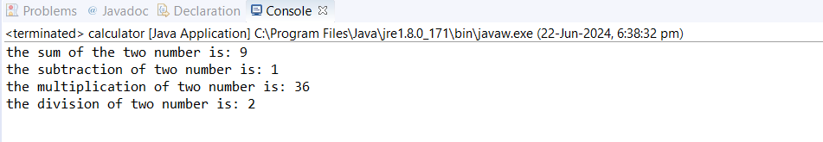

QUE6:-Write a java program to check if a given number is prime or not

INPUT:- **package** narrowingWidening;

**public** **class** PrimeNumber {

**public** **static** **void** main(String[] args) {

// **TODO** Auto-generated method stub

**int** limit = 100; // Change this value to print prime numbers up to a different limit

System.***out***.println("Prime numbers up to " + limit + " are:");

**for** (**int** num = 2; num <= limit; num++) {

**if** (*isPrime*(num)) {

System.***out***.print(num + " ");

}

}

}

**public** **static** **boolean** isPrime(**int** number) {

**if** (number <= 1) {

**return** **false**;

}

**for** (**int** i = 2; i <= Math.*sqrt*(number); i++) {

**if** (number % i == 0) {

**return** **false**;

}

}

**return** **true**;

}

}

OUTPUT:-

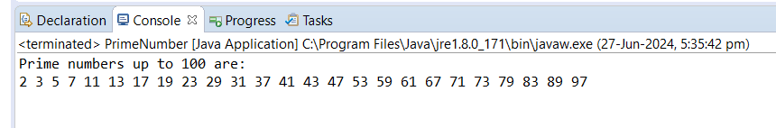

QUE7:- Write a java program that compares two numbers and prints the larger one.

INPUT:-

**package** greatestNumber;

**public** **class** GreatestNumber {

**public** **static** **void** main(String[] args) {

// **TODO** Auto-generated method stub

**int** a=8,b=0;

**if**(a>=b) {

System.***out***.println("a is greater than b");

}

**else**{

System.***out***.println("b is greater than a");

}

}

}

OUTPUT:-

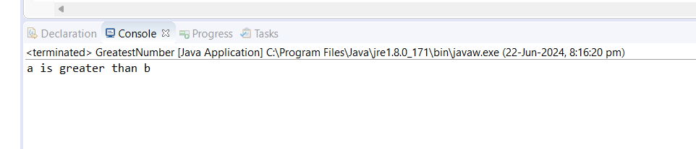

QUE8:-Write a java program that takes an age input from user and determine if they are eligible to vote (considering the legal voting age)

INPUT:-

**package** votingProgram;

**import** java.util.Scanner;

**public** **class** VotingProgram {

**public** **static** **void** main(String[] args) {

// **TODO** Auto-generated method stub

Scanner sc=**new** Scanner(System.***in***);

System.***out***.println("please enter the age");

**int** age=sc.nextInt();

**if**(age>=18) {

System.***out***.println("you are eligible for voting");

}

**else** {

System.***out***.println("you are not eligible for voitng");

}

sc.close();

}

}

OUTPUT:-

